The Global Social Justice Coalition presents:
“UNITED NATIONS SUNDAY: ENGAGING IN GLOBAL SOCIAL JUSTICE”
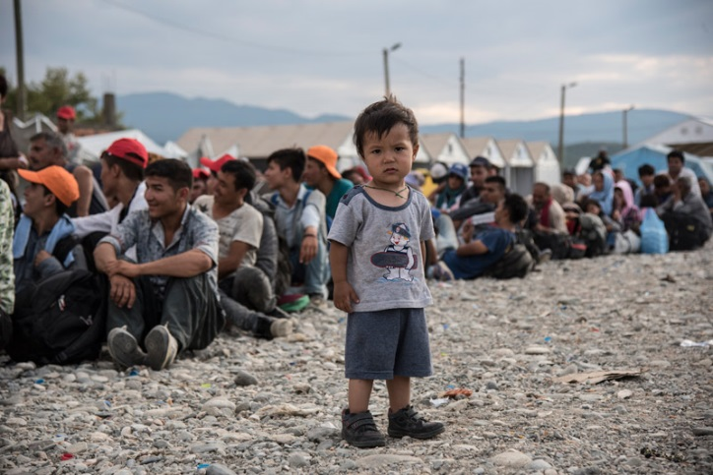
1.00 – 3.00 PM, SUNDAY OCTOBER 28,
Buchan Reception area, First Unitarian, 1011 SW 12th
Refreshments provided

The United States MUST be more than “America First!” Learn how we can support the work of the United Nations in addressing immigration issues, the global impact of climate change, humanitarian aid for refugees and much more.
Speaker Yashar Vasef, past president, Portland United Nations Association; panelists: Curt Bell, UUs for Justice in the Middle East; Marlene Anderson, the Imani Project; Wendy Rankin, Immigrant Justice Action Group; Susan Romanski, Mercy Corps.
Meet local representatives of global social justice action groups and discover how you can engage here in Portland to make a difference globally.

